**Full Stack Development with MERN**

**Project Documentation format**

**1. Introduction**

* **Project Title:** Freelancing application - Mern
* **Team Members**
* Jayapreetha - Frontend
* Meghaa-Backend
* Sahana-Backend
* Yuvashree S-Frontend

**2. Project Overview**

* **Purpose:** A freelancing web application development project aims to connect clients with skilled web developers, offering a secure platform for project posting, hiring, and payment. It enables freelancers to find work, build portfolios, and gain experience while providing businesses with scalable development resources. Through features like escrow payments, collaboration tools, and milestone tracking, the platform fosters trust and efficient project management.
* **Features:** A freelancing web app should include user profiles, job posting, secure escrow payments, messaging, and a review system for efficient project matching and collaboration. Admin tools and dispute resolution features support smooth operations and fair transactions.

**3. Architecture**

* **Frontend:** HTML, CSS, JavaScript, React
* **Backend:** Node.js, Express, MongoDB, JWT, Twilio
* **Database:** The database used in this freelancers' website is **MongoDB**. It’s a NoSQL database suitable for handling large amounts of unstructured or semi-structured data, making it a popular choice for web applications that need flexibility and scalability, such as freelancing platforms.

**4. Setup Instructions**

To develop a freelancing web application with the specified tech stack, these are the key prerequisites:

**Technical Knowledge:**

* **Web Fundamentals**: Proficiency in HTML, CSS, and JavaScript.
* **Front-End Framework**: Experience with **React** for building dynamic user interfaces.
* **CSS Styling Libraries**: Familiarity with **Styled Components** and **MUI** for styling React components.
* **Server-Side Development**: Knowledge of **Node.js** and **Express** for backend logic and API creation.
* **Database Management**: Understanding of **MongoDB** for data storage and retrieval.
* **Authentication & Authorization**: Knowledge of **JWT** for secure user authentication.
* **Communication API**: Familiarity with **Twilio** or similar APIs for SMS/email notifications
* **Installation:** Create config. env file in backend folder and Fill your . env variables:

PORT=

DATABASE=

SECRET_KEY=

* **Install deps:** npm install
* **Run React server from Client folder** : npm start
* **Run Node.js Server** : node server.js

**5. Folder Structure**

* **Client:** The **client** folder contains components, pages, services, and styles, with React managing the UI and Axios for API calls.
* **Server:** The **server** folder includes configurations, models, controllers, routes, and middleware for handling database, authentication, and business logic.

**6. Running the Application**

* + **Frontend:** Navigate to the client directory and run npm start to start the React development server.
  + **Backend:** Navigate to the server directory and run npm start to start the backend server.

**7. API Documentation**

* The API documentation for a freelancer web application includes endpoints for user authentication (login, signup), project management (create, update, delete projects), and bidding (submit bids, view proposals). It specifies the HTTP methods, request bodies, and response formats, along with authentication using JWT for secure access. Example responses for success and error codes help developers integrate with the backend efficiently.

**8. Authentication**

Authentication for a freelancer application typically involves:

1. **User Registration**: Users (clients or freelancers) create an account by providing their details (email, password, etc.). The password is securely hashed using a library like bcryptjs, and the user data is stored in a database (e.g., MongoDB).
2. **Login**: Users log in by providing their email and password. The server compares the entered password with the hashed password stored in the database. If the credentials are valid, a JWT (JSON Web Token) is generated and sent to the client for authentication.
3. **JWT Authentication**: The client stores the JWT (typically in local storage or cookies) and includes it in the Authorization header for future requests to protected routes. The server verifies the token on each request to ensure the user is authenticated.
4. **Protected Routes**: Certain routes, like posting projects or bidding, are accessible only to authenticated users. A middleware (e.g., authMiddleware.js) is used to check if the request contains a valid JWT and grant access accordingly.
5. **Logout**: Users can log out by deleting the JWT from their client-side storage, effectively ending the session.

**9. User Interface**

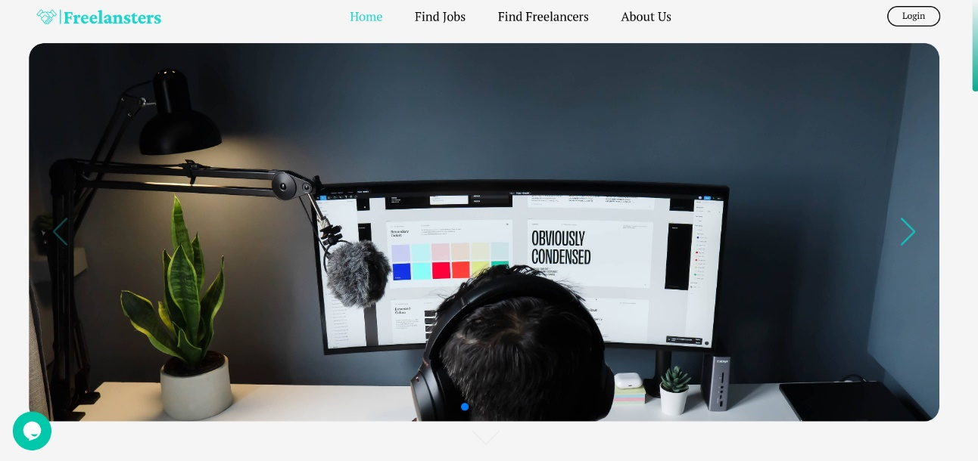

**10. Testing**

Testing for a freelancer web application involves unit tests for individual components (using tools like Jest and React Testing Library), integration tests to ensure backend APIs (like project creation or bidding) function as expected, and end-to-end testing with frameworks like Cypress to simulate user flows (login, project posting, etc.). Automated tests help catch bugs early, improve reliability, and ensure smooth user experience. Regular testing of security features like JWT authentication and payment processes is crucial for protecting user data.

**11. Screenshots or Demo**

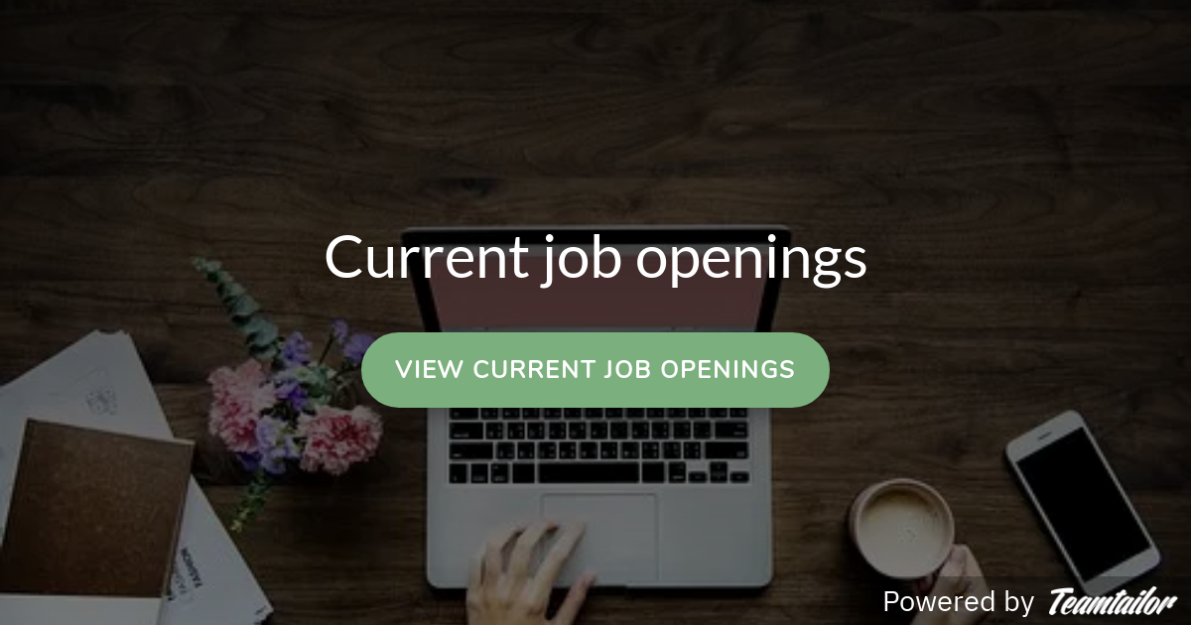

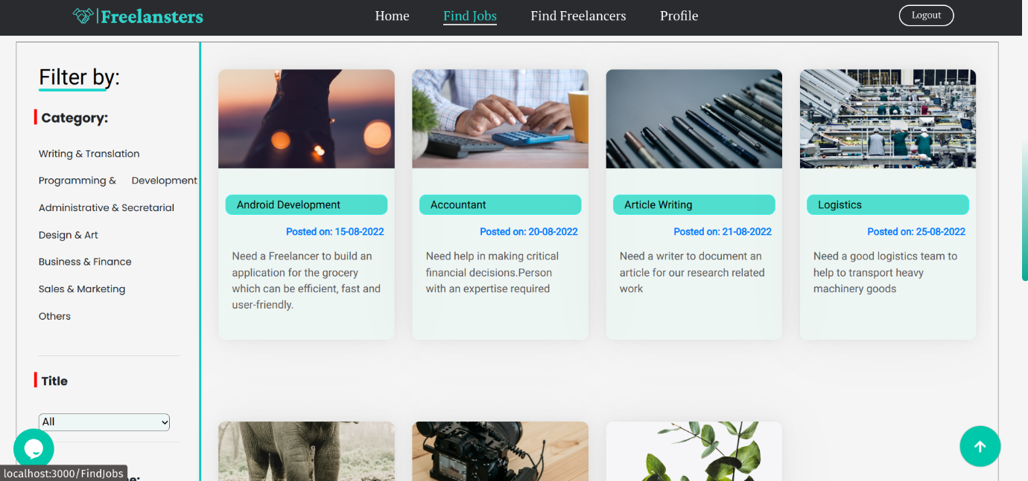

**12. Known Issues**

Common known issues in a freelancing web application include:

1. **Payment Processing Errors**: Issues with payment gateways or incorrect milestone tracking can delay transactions or cause payment disputes.
2. **Authentication Failures**: Bugs in the login/signup process or JWT token handling may lead to unauthorized access or session timeouts.
3. **Project Visibility**: Freelancers may not see relevant projects, or clients may struggle to manage project visibility due to inefficient filtering or search functionality.
4. **Communication Delays**: Problems with real-time messaging or email notifications can hinder communication between clients and freelancers, affecting project timelines.
5. **Profile Verification**: Incomplete or inaccurate freelancer profiles can cause trust issues or mismatches between clients and freelancers, leading to dissatisfaction.
6. **Mobile Responsiveness**: The application may not perform well on all devices, leading to a poor user experience on mobile or tablet views.
7. **Dispute Resolution**: Inconsistent or slow dispute resolution processes can affect trust and cause frustration among users.

**13. Future Enhancements**

Future enhancements for a freelancer web application could include:

1. **AI-Powered Job Matching**: Implement machine learning algorithms to match freelancers with projects based on skills, past performance, and preferences for more accurate job recommendations.
2. **Mobile App Development**: Create dedicated iOS and Android apps for better user engagement and accessibility on the go.
3. **Video Conferencing Integration**: Add built-in video calling and screen sharing features for seamless communication between clients and freelancers during the project.
4. **Advanced Search Filters**: Introduce more granular search options, such as skills, ratings, hourly rate, location, and availability, for both clients and freelancers.
5. **Real-Time Collaboration Tools**: Implement tools like shared task lists, time tracking, and document collaboration (e.g., Google Docs integration) to streamline project management.
6. **Blockchain for Payments**: Use blockchain technology to facilitate secure, transparent, and faster transactions, ensuring the protection of user funds.
7. **Gamification and Rewards**: Introduce badges, leaderboards, and a reputation system to incentivize high-quality work and engagement from freelancers.
8. **Dispute Resolution with Arbitration**: Implement an integrated arbitration system with a neutral third-party mediator to resolve disputes between clients and freelancers more efficiently.
9. **Multi-Language Support**: Add multi-language functionality to reach a global audience, enhancing usability for non-English-speaking users.